

CSE 251

Electronic Devices & Circuits

Software Lab

*Prepared by:*

**Name: MD. NEFAUR RAHMAN LABIB**

**ID: YK I’M NOT DUMB ENOUGH TO GIVE MY ID**

*Submitted to:*

You … well duh !

**Study of Diode Characteristics:**

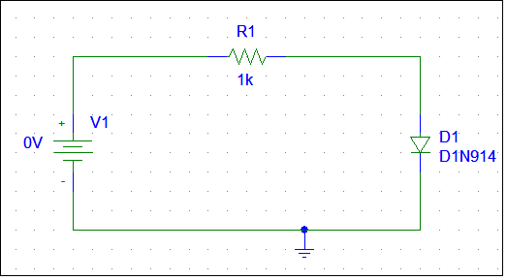



Diode I-V Characteristics (Circuit & Graph)

**Study of Half-Wave and Full-Wave Diode Rectifier Circuit:**

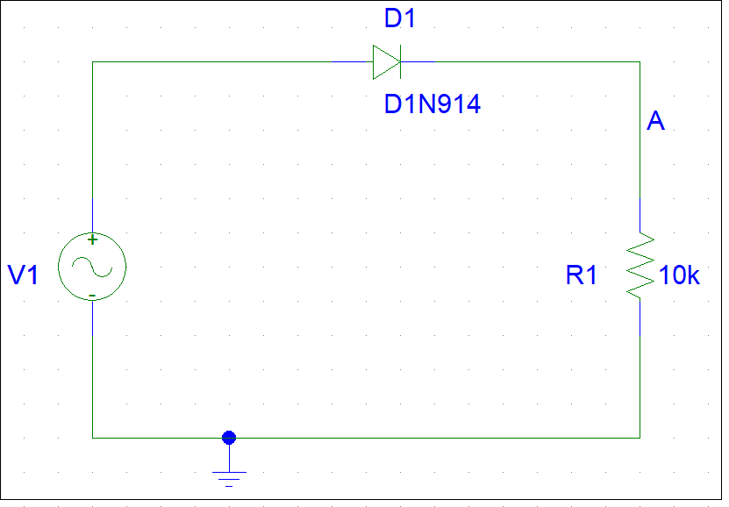



Half Wave Rectifier (Circuit & Graph)

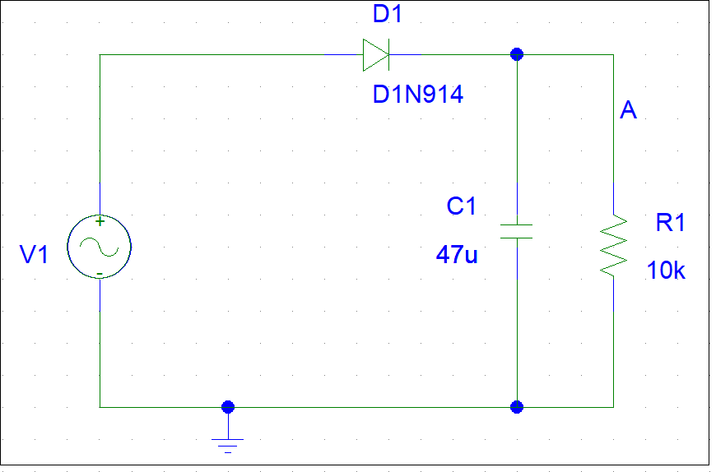



Half Wave Rectifier with Capacitor (Circuit & Graph)

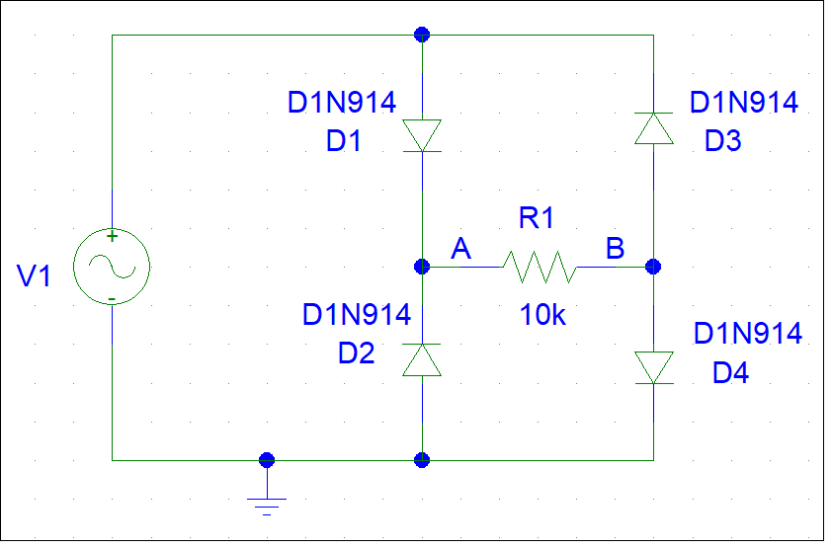



Full Wave Rectifier (Circuit & Graph)

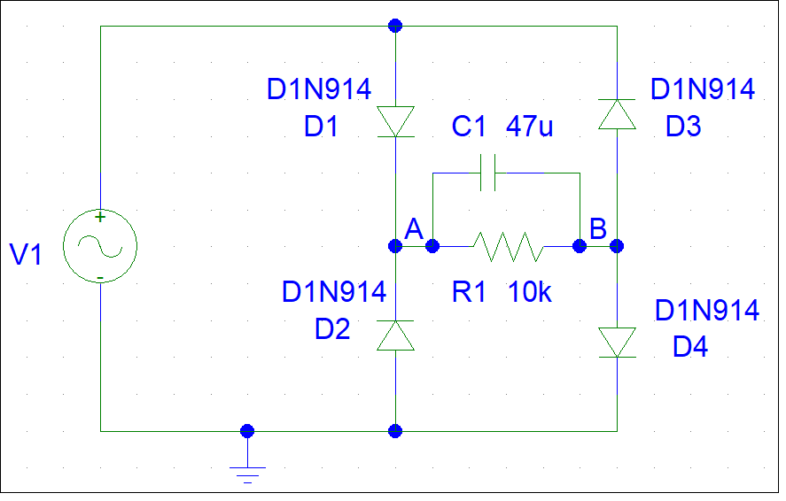



Full Wave Rectifier with Capacitor (Circuit & Graph)

**Study of Clipper & Clamper Circuit:**

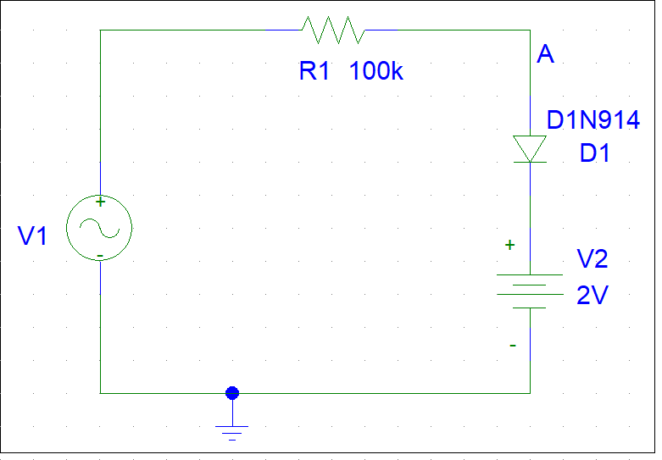



Positive Clipper (Circuit & Graph)

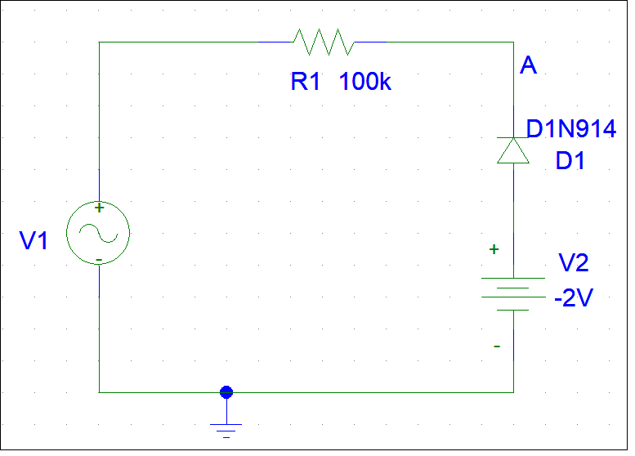



Negative Clipper (Circuit & Graph)

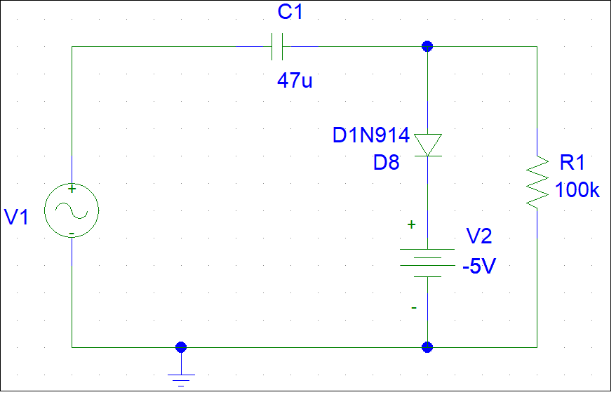



Positive Clamper (Circuit & Graph)

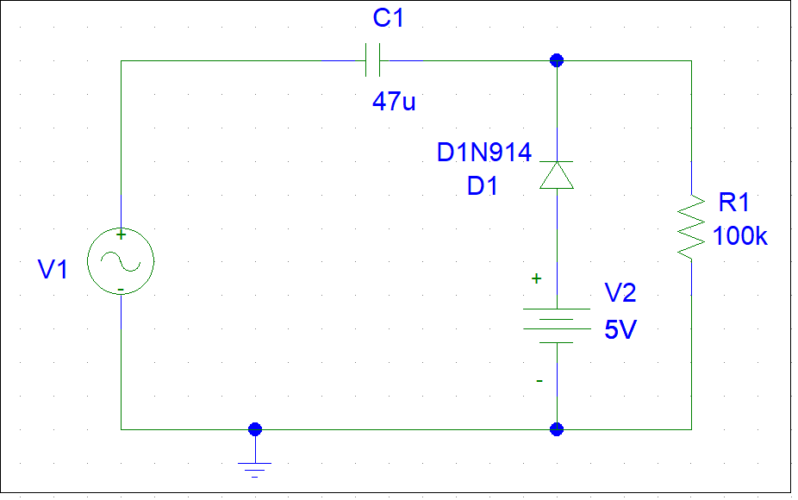



Negative Clamper (Circuit & Graph)

**Study of Zener Diode Characteristics:**

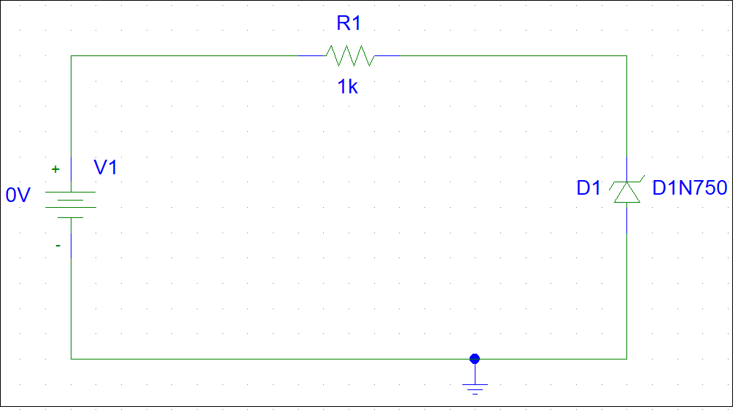



Zener Diode Backward Bias I-V Characteristics (Circuit & Graph)

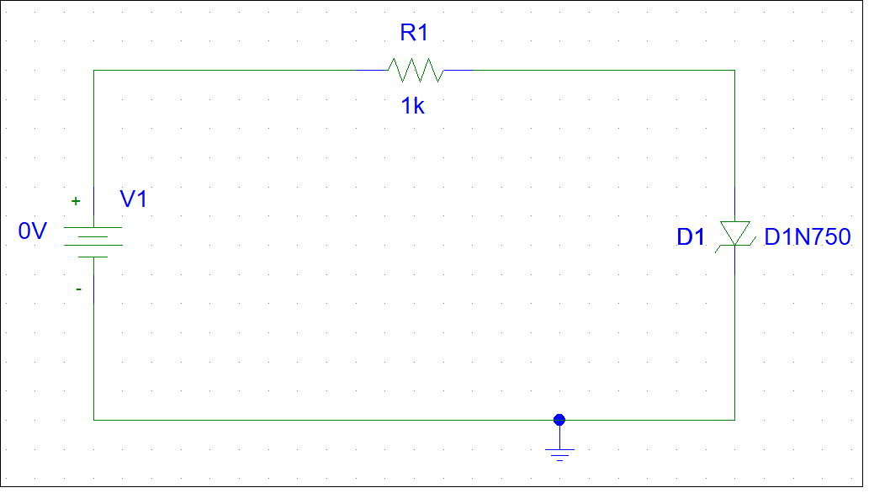



Zener Diode I-V Characteristics (Circuit & Graph)

**Study of Voltage Regulator Characteristics:**

Line Regulation:

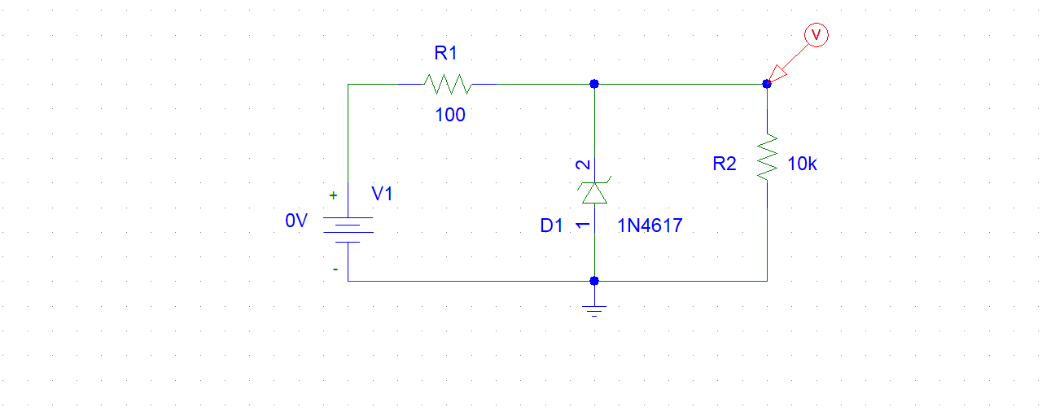

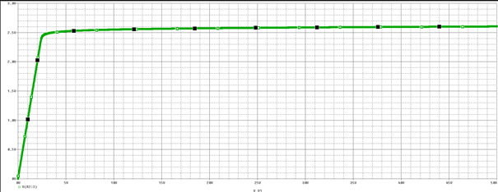

Load Regulation:

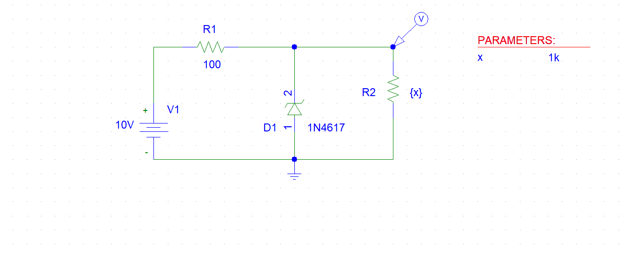

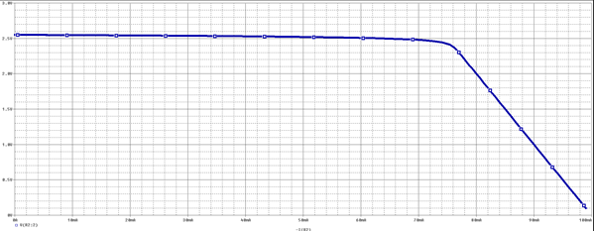

**Study of BJT Transfer Characteristics:**

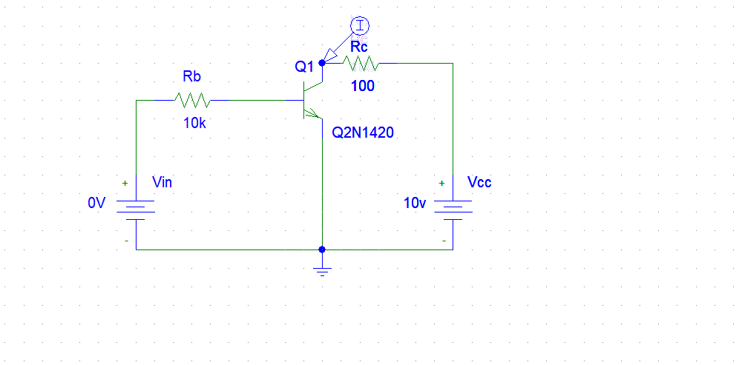

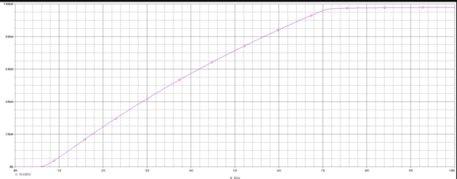

**Study of BJT Output Characteristics:**

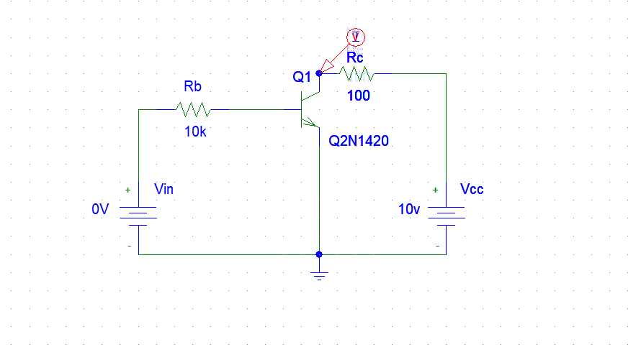

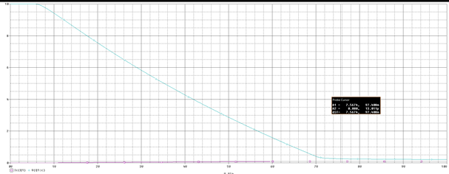

**Study of MOSFET Transfer Characteristics:**

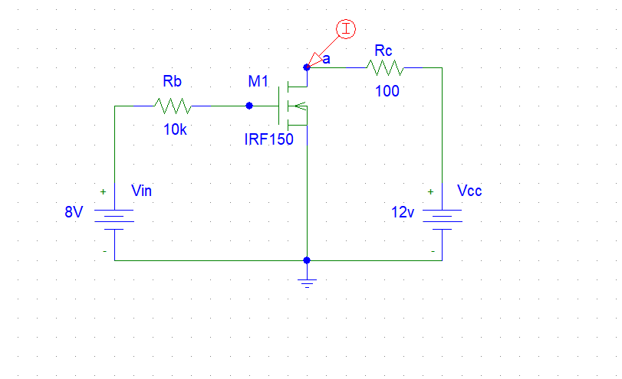

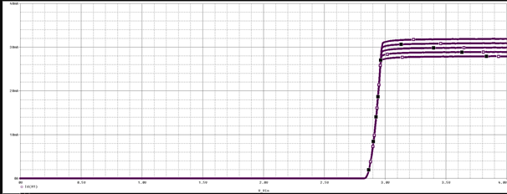

**Study of MOSFET Output Characteristics:**



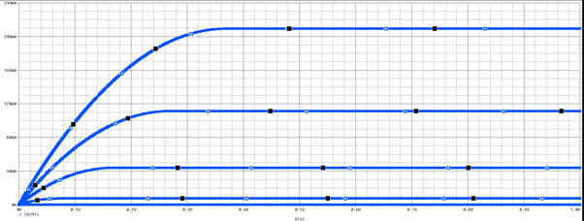

**Study of Amplifier Characteristics:**

Without Biasing:

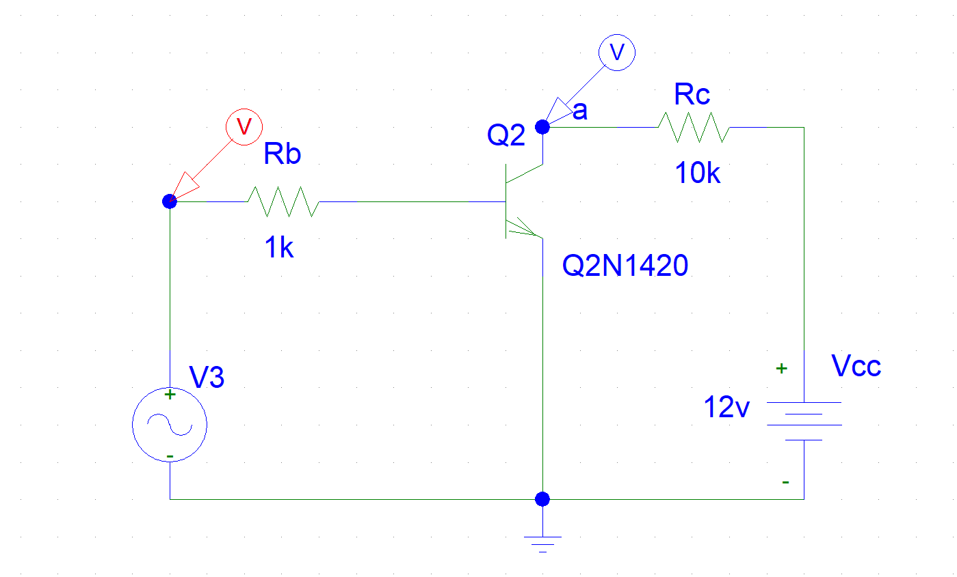

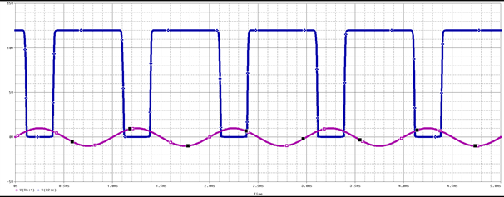

With Biasing:

